Text runs into the next Cell

A common problem in spreadsheets is that your text may run over more than one cell.

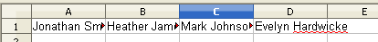

To Fix this problem you can double click between the cells which will automatically increase the cell width to the cell with the longest text. Move the cursor to the line between the cells you want to increase, then when it changes to a double arrow, double click.

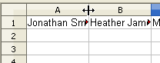
This will only change the cell to the right of the cursor. If you want to do all the rows/columns at one time highlight the table or rows and then double click as before.

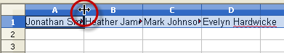

You can also go to the Format Menu and Select Column > Width and manually change the size of the column

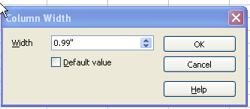

The last option allows you to manually drag the column width. Once again move the cursor to the line between the cells. Instead of double clicking, hold the mouse button down and drag it to the right to the length you desire.



